Implementation of management plan for the Lake Engure Nature Park

Project LIFE00/NAT/LV/7134

FIRST INTERIM ACTIVITY REPORT WITH PAYMENT REQUEST
Covering period 1 October 2001 – 31 August 2002

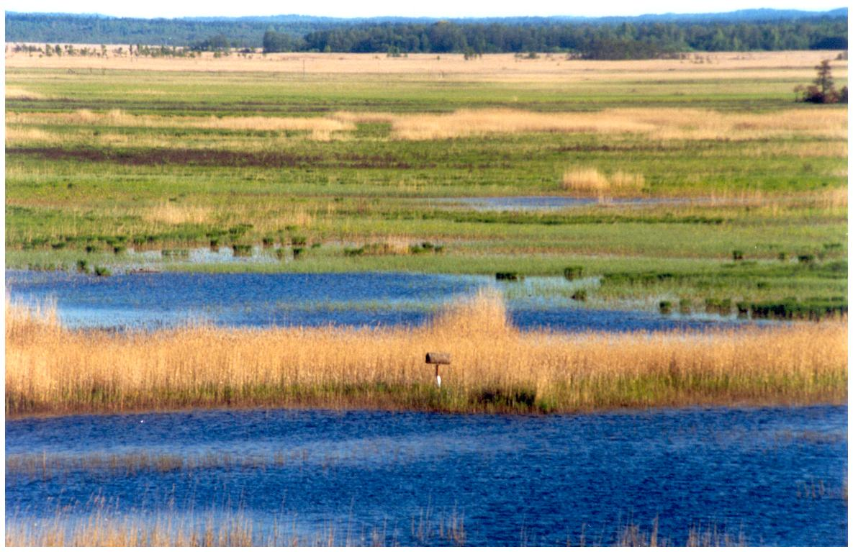

Date of the report: 15 September 2002.

Report compiled by: Inga Račinska, project manager, Latvian Fund for Nature.
Address: Kronvalda blvd. 4, Riga LV-1050, LATVIA
Tel: +371 7 034894 Fax: +371 7 830291 E-mail address: inga@lanet.lv

 |  | 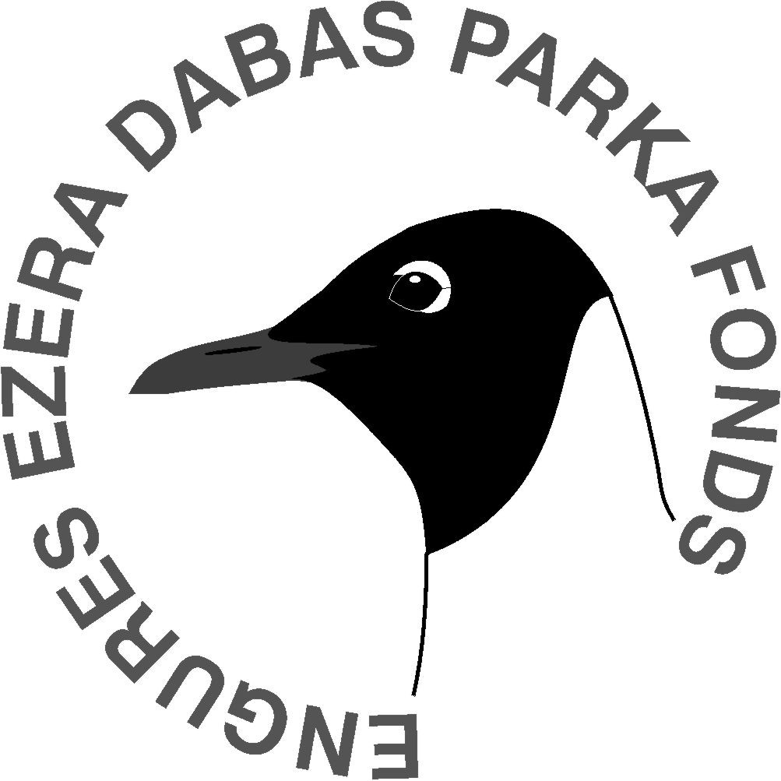

Table of Contents

Section 1. INTRODUCTION 3
1.1. Background to the project 3
1.2. Overview of main conservation issues being addressed 3
1.3. Objectives of the project as defined in application 5
Section 2. SUMMARY 6
2.1. Summary of the activities during report period 6
2.2. Summary table of activities 7
2.3. Milestones during report period and checklist of identifiable products 8
2.3.1. SUMMARY OF PROJECT MILESTONES 8
2.3.2. SUMMARY OF DELIVERABLE PRODUCTS 8
2.4. Problems or difficulties expected 9
Section 3. TECHNICAL REPORT (BY ACTIVITY) 10
A. Preparatory actions, elaboration of management plans and/or of action plans 10
B. Purchase/lease of land and/or rights 11
C. Non-recurring management 12
D. Recurring management 15
E. Public awareness and dissemination of results 18
F. Overall project operation 24
APPENDIX 27
Appendix 1 – MAPS 28
Appendix 2 – PICTURES 30
Appendix 3 – CONTRACTS 42
Appendix 4 – BOOKLET 43
Appendix 5 – SEMINAR 44
Appendix 6 – CV OF THE PROJECT STAFF 47
Appendix 7 – PROGRAM OF THE STUDY TOUR TO HIIUMAA, ESTONIA 51
Appendix 8 – PRINTOUTS OF THE HOME PAGE 52

Section 1. INTRODUCTION

  - Background to the project

The Lake Engure is unique European wetland and one of the most important nature protection sites in Latvia. It has been nationally protected since 1957 (bird reserve 1957–1998, nature park since 1998). Lake Engure is also the Ramsar site since 1995 when Latvia joined the Convention, the Important Bird Area and the potential Natura 2000 site. The site holds 15 species and 3 habitats of Community importance listed in Bird and Habitat Directives, as well as 18 species of Bern Convention.

Both, national and international nature conservation authorities have recognized the importance of this site. It resulted in several projects for conservation and management funded by both national and international organisations. The most recent of these projects was the elaboration of Management Plan for Lake Engure Nature Park funded by the Swedish Environmental Protection Agency and Latvian Environmental Protection fund. LIFE project is based on this management plan, it aims at implementation of the most urgent management measures foreseen in the management plan, elaborated by joint efforts of Latvian Fund for Nature, Ministry of Environmental Protection and Regional Development of Latvia and local communities. The objective of the plan is the conservation of 5 fish and 3 plant species listed in the Annex 2 of Directive 92/43/EEC, 3 bird species of Directive 79/409/EEC and 18 habitats listed in the Annex 1 of Habitats Directive. Management actions proposed in the plan will contribute to the economic development of the region bringing more income and creating new jobs in the region with high unemployment level.

  - Overview of main conservation issues being addressed

Main threats to the biological diversity and the amount of bird populations in the Lake Engure Nature Park are overgrowing of the lake by reed, overgrowing of meadows both at the lake and sea. Lack of public involvement and awareness is obstacle to successful implementation of regulations and the management plan.

Overgrowing of the lake by reed, merging of separate reed-beds is considered very significant threat to the lake Engure. Main causes of the overgrowing are lowering of lake levels in 1842, intensive pollution with nutrients from agricultural runoff in the 1960s - 1980s, accumulation of organic material in lake sediments and termination of reed harvest. Project is addressing this threat by actions C.2., D.2. and D.3.

Loss of meadow habitats and overgrowing of calcareous fens is another dangerous trend, leading to disappearance of such bird species as Crex crex and all Limicolae species, as well as numerous plant species, such as Liparis loeselii (L.) Rich and others. Several habitats of Community importance are in danger of disappearing due to this threat, such as Boreal Baltic coastal meadows, Molinia meadows on calcareous, peaty or clayey-silt-laden soils, Northern boreal alluvial meadows and Calcareous fens with Cladium mariscus and species of the Caricion davalliana. Project is addressing this threat by actions A.1., A.2., C.1., C.3., C.4., D.1. and D.3.

Uncontrolled, illegal and increasing rate of forest cutting is nationwide threat and the result of such actions is that the mid-aged, old and over-age stands have very few elements favouring biological diversity: (large trees, standing dead trees, broken stems, wind-throws of old age, trees with hollows (>25 cm diameter). Therefore, there are no forests that have developed in the longer term without anthropogenic impact. As a result of sanitary cutting, in most of the territory, stands have low stem density, stumps of variable age, stumps from wind-broken trees, and the vegetation has been disturbed by vehicles.
A negative trend that has been increasing in importance since renewal of independence is uncontrolled harvest by private forest owners. Continuation of this process, together with further drainage of forests would intensify the threat to biological diversity in the Lake Engure Nature park forests, and such important habitats as Transition mires and quaking bogs, Alluvial forests with Alnus glutinosa and Fraxinus excelsior (Alno-Padion, Alnion incanae, Salicon albae, Fennoscandian deciduous swamp woods and Bog woodland.
This threat is addressed by actions A.1., B.1. and D.4.

Many habitats and species are influenced by violation of the nature protection regime in Lake Engure Nature park. By actions D.4. and E.3. , project is addressing following threats:
- Violation of fishing and hunting regulations (violation of allowed net length limits, angling and net fishing out of season or in forbidden locations, use of banned fishing instruments and unregistered fishing craft),
- Violation of hunting regulations (hunting in the restricted nature protection territory, use of electrical engines during hunting, use of banned ammunition types),
- Violation of regulations concerning boating stations (allowed boat number exceeded, clients are not informed of regulations).

Uncontrolled tourism and visitor activities along the sea is another nationwide threat, endangering many important coastal habitats, such as Embryonic shifting dunes, Shifting dunes along the shoreline with Ammophila arenaria (white dunes), Fixed coastal dunes with herbaceous vegetation (grey dunes), Wooded dunes of the Atlantic, Continental and Boreal region.

The negative effects have been caused by the following factors:
- insufficient number of recreational sites with public services along the seashore,
- insufficiently developed seashore management (refuse collection, regeneration and tending of recreational sites),
- lack of information and control (insufficient information on the LENP regulations regarding protection and use, and insufficient information on beach and dune ecology, plants and animals).
Project is addressing the issue by providing more information about the regime and values, establishing infrastructure for nature friendly tourism, as well as by enforcing the control in the LENP (Actions D.4., E.1., E.2., E.3., E.4., E.5., E.6., E.7., E.8. and E.9.).

  - Objectives of the project as defined in application

Objectives of this project are as follows:
- Protection of rare and endangered habitats and species,
- Restoration and maintenance of 107 ha of meadows,
- 50 ha of especially valuable forest saved from cutting,
- At least 2000 visitors per year visiting the Lake Engure Nature Park thus contributing to the economic development of the region,
- Basis for further education and management of the Lake Engure Nature Park.

Section 2. SUMMARY

2.1. Summary of the activities during report period

Project “Implementation of management plan for Lake Engure Nature park” was launched in October 2001. Most of the activities, foreseen in project proposal have been successfully undertaken to date and described in following sections. Also those of the activities, modified or delayed are described in following sections.

The project is based on Management plan for Lake Engure Nature park (LENP), elaborated by Latvian Fund for Nature in cooperation with Swedish EPA, Ministry of Environment and local communities. Project is implementing most of the urgent management measures, foreseen in management plan, in order to address main threats to nature values of LENP.

Among main management activities, such actions as reed cutting, restoration and maintenance of coastal and shore meadows, protection of forests and development of nature tourism should be mentioned as most significant. Engure project is the first project in Latvia, introducing the system of breeding meet cattle for nature conservation purposes, combined with support to farmers. Due to the fact that there is no experience of this kind of activities in Latvia, it is hard to foresee the effects of different activities performed in the project. Nevertheless, the experience of Engure project have been already used as example, when planning management measures in other protected areas, such as North Gauja, Lielupe floodplain meadows and others.

The Study Tour (Action F.3.) was very useful for project staff to gain more experience in management of meadows by grazing. We went to Estonia to learn from experience of Matsalu reserve and Hiiumaa island in cattle breeding in cooperation with local farmers.

Engure project is playing major role in developing semi-natural grazing approach in protected areas. Several protected areas have been asking for our advice on nature management by grazing. Nature conservationists from all regions of Latvia were able learn from our experience, as they were presented the first results of the project during the seminar organised in August (Action E.7.).

Project activities are serving the purpose of demonstration activities, especially all the recurring and non-recurring biotope management actions – reed cutting, restoration of meadows, introducing the cattle. The reed cutting machine bought for the project is the first one of this kind in Latvia.

The project have been presented in several seminars in Latvia, as well as in seminar “Management of meadows – Nordic and Baltic solutions”, organised in Saaremaa (Estonia) in 28- 31 August, 2002. Project will be also presented in poster format during Ramsar 8th Conference of Parties, held in Valencia, Spain in 18-26 November, 2002.

We are describing the progress of the project activity by activity in following sections, according to project proposal. Any additional information to the description of activities, such as pictures, copies of contracts, maps etc. is attached in Appendixes 1-7.

2.2. Summary table of activities

Number of action | Action | Time plan | Status
A.1. | Digital mapping of habitats of Community importance in LENP | II-IV 2002 | In progress
A.2. | Agreements and contracts with local farmers about keeping the cattle of LENP | IV 2001 – I 2002 | Delayed until 2003
B.1. | Purchase of forest land from 5 private owners in reserve zone | IV 2001 – I 2002 | Delayed until 2003
C.1. | Restoration of shore meadows, calcareous meadows and meadows on islands | I-II 2002 | Accomplished in August 2002.
C.2. | Purchase of reed cutting machine | IV 2001 – II 2002 | Accomplished in June 2002
C.3. | Purchase of cattle for grazing management in LENP | I-II 2002 | Accomplished in January-August 2002
C.4. | Building of fences for keeping the cattle | II 2002, I 2003, I 2004 | Accomplished in June 2002, next fence planned in I 2003.
D.1. | Maintaining shore, island and coastal meadows and calcareous fens by grazing | III 2002 – III 2004 | In progress
D.2. | Reed cutting | III 2002, III 2003, III 2004 | In progress
D.3. | Monitoring the effect of management measures on habitats and species | II 2002 – III 2004 | In progress
D.4. | Ensuring adequate control and protection in LENP | IV 2001 – III 2004 | In progress
E.1. | Building of summer lecture room | I-II 2002 | Delayed. Planned to be delivered in September 2002.
E.2. | Construction of 2 bird watching towers | I 2002, I 2003 | 1st tower finished in September 2002
E.3. | Setting up notice boards and border signs at LENP | IV 2001 – I 2002 | In progress. Delayed.
E.4. | Construction of nature/tourist path | I-II 2003 | Planned
E.5. | Printing 3 booklets about LENP and project | IV 2001, I 2003, II 2004 | 1st booklet printed in IV 2001, next booklets planned to be delivered in time
E.6. | Publication of park periodical | I 2003 – III 2004 | Planned
E.7. | Organising seminars | IV 2001, I 2003, II 2004 | 1st and 2nd seminar organised, 3rd planned to be delivered in time
E.8. | Film about LENP | II-III 2003 | In progress
E.9. | Creating home page of LENP and LIFE project | IV 2001 | Delayed. Home page launched in September 2002
F.1. | Monitoring of project performance | III 2002, III 2003, III 2004 | In progress
F.2. | Administration of the project | IV 2001 – III 2004 | In progress
F.3. | Study Tours | IV 2001, II 2002 | Delayed. 1st Study Tour organised in July 2002
F.4. | Independent audit of the project | III 2004 | Planned

2.3. Milestones during report period and checklist of identifiable products

2.3.1. SUMMARY OF PROJECT MILESTONES

Milestone | Number of action | Planned | Accomplished
Valuable forest compartments bought for protection | B.1. | March, 2002 | Planned in 2003.
First meadow habitats restored (The wet shore meadow north of the Ornithological station, including a strip of pine forest) | C.1. | June, 2002 | August, 2002
Reed cutting machine bought | C.2. | June, 2002 | June, 2002
Cattle for grazing bought | C.3. | June, 2002 | January – August 2002
Summer lecture room built | E.1. | June, 2002 | Planned in October, 2002
First bird watching tower constructed | E.2. | March, 2002 | Will be finished in September, 2002
Second bird watching tower constructed | E.2. | March, 2003 | -
Tourist path constructed | E.4. | June, 2003 | -
Project introduction seminar conducted | E.7. | December, 2001 | January, 2002
2nd project seminar conducted | E.7. | March, 2003 | August, 2002
Final project seminar conducted | E.7. | September, 2004 | -
Film about Lake Engure Nature park and project ready | E.8. | September, 2003 | -

2.3.2. SUMMARY OF DELIVERABLE PRODUCTS

Product | Number of action | Planned | Accomplished
Black and white booklet about LIFE project | E.5. | 31 November, 2001 | 19 November, 2001
Home page of LENP and project | E.9. | 31 December, 2001 | Launched in September, 2002
Digital map with habitats of Community importance in LENP | A.1. | 31 December, 2002 | -
Full color booklet about LENP and project | E.5. | 15 February, 2003 | -
Film about Lake Engure Nature park | E.8. | 30 September, 2003 | -
Full color booklet about results of project | E.5. | 30 September, 2004 | -

2.4. Problems or difficulties expected

There are no major difficulties recognized at this stage of the project. Some of the actions have been slightly delayed, for different reasons. But all these delays are being dealt with and will not be the reason for any major changes in the project.

The support of local population is very important for the project and, as underlined by 2nd project seminar (Action E.7.) people still lack information. Project staff will be working on this issue in coming months, to provide first hand information to local population (mainly with help of local newspapers).
Section 3. TECHNICAL REPORT (BY ACTIVITY)

A. Preparatory actions, elaboration of management plans and/or of action plans

ACTION A.1:

Name of action: Digital mapping of habitats of Community importance in LENP
Time plan: II-IV 2002

Progress: Forest habitats of Community importance have been checked in nature during 2002 field season. The reports from experts are due in September and data will be incorporated in GIS maps. Data on meadow habitats will be obtained in co-operation with project National Grassland inventory. Although their data will not be fully applicable for the project (it is not as detailed as requested in our project and they are focusing not only on habitats of Community importance), the cooperation between our experts is launched and we are planning to complete their data to the level of detail needed for Engure LIFE project. EC habitats 7210 and 7230 have been mapped in LENP. Also dune habitats have been checked and will be incorporated in maps by December 2002.

Variations/complications/delays: NO
Additional information: NO

ACTION A.2:

Name of action: Making agreements and signing contracts with local farmers about keeping the cattle owned by LENP
Time plan: IV 2001 – I 2002

Progress: It was agreed that no contracts will be signed yet. The reason for such a decision is that in 2002 only first cattle is arriving in LENP and project staff has not yet gathered enough experience with the cattle keeping, to be able to foreseen all the possible constraints. Also, the first meadow to be restored and maintained by grazing is located near Ornithological station, on the east coast of the lake, in distance from any villages. In this case it is more appropriate that project staff itself is taking care of the animals, placed on this first meadow. Another very important reason for not involving farmers directly during this first year of cattle keeping is that people have lost the traditions of cattle keeping. Due to agricultural policies in Soviet times, people were discouraged to keep their own cattle. Nowadays, there is no cattle in villages Mērsrags and Bērzciems on the eastern coast of the lake. And local people are rather sceptical about re-introducing the cattle farming around the lake Engure. The best method to get them involved is by showing that cattle breeding can be profitable and that it can be sustained. In year 2002 we have done a lot of talking to convince the people, but they want to see how it works in nature, before signing up for anything as unusual as meat cattle keeping for profit and nature conservation at the same time. So, the first cattle and the first meadow is serving also as demonstration to local people to convince them that cattle breeding may be an challenging option to earn for the living.

Next meadow to be restored in 2003 is located on the other coast of the lake, near village Ķūļciems (please refer to Area #2 in description of Action C.1). Only few farmers have remained the cattle keeping traditions in this village and people are careful about the possibilities to take care of the cattle. But we are working with the community and 2 persons from this village have been already taken to the Study Tour in Estonia (for more information on Study Tour, please see Action F.3.). These 2 persons will be organizing the meeting for local farmers, presenting their experience from the Study Tour. The meeting is planned in September.

Therefore, we hope that by 2003, when next meadow is planned to be restored and maintained by grazing, we will have the contracts signed with farmers willing to try the cattle breeding, in cooperation with our project.

Variations/complications/delays: Activity will be delayed until 2003, due to reasons described in Progress section. The potential complications could arise if no farmers will be capable or willing to be involved in the project. But this is not likely, if we continue providing people with enough information and demonstration activities.
Additional information: NO

B. Purchase/lease of land and/or rights

ACTION B.1:

Name of action: Purchase of land from 5 private owners of forests in reserve zone where no management is allowed.
Time plan: IV 2001 – I 2002

Progress: When we begun to prepare the first documents, we found out that, by Latvian legislation, NGOs are not allowed to buy the land in nature reserve zones. Unfortunately, this constraint was not discovered during preparation of the project proposal. Nevertheless, the action will not be cancelled, just postponed until the necessary documentation will be prepared to conduct this purchase. Ministry of Environment and Regional Development is currently working on finding the solution for this problem. One of the potential solutions is that the Regulation of the Cabinet of Ministers will be issued, concerning this separate case and the land will be bought on the name of the Ministry.
Last discussions with owners of the forest compartments were conducted in July 2002 – they are still willing to sell their forest and waiting for further developments. We promised that purchase will be conducted, but informed also about the constraints we are facing.

Variations/complications/delays: Activity will be delayed until 2003 due to reasons mentioned in Progress section.
Additional information: NO

- Non-recurring management

ACTION C.1:

Name of action: Restoration of shore meadows, calcareous meadows and meadows on islands
Time plan: I-II 2002

Progress:
Description of areas to restore listed in priority order with specific actions for restoration:
In year 2002:
#1. The wet meadow north of the Engure Ornithological Research Centre, 20ha – cutting of bushes.
In following years:
#2. The wet meadow on the western side of the lake, 20 ha. Cut trees and bushes.
#3. Calcareous meadows, including a calcareous pine forest, 25-50 ha. Cut small pine trees on fens.
#4. Expand the meadow described in point 1 to the north of the bird-watching tower, 5 ha. Cut bushes on meadow.

The first meadow has been partly restored in May-June, 2002. Local people were employed to perform this task. Some bushes have been left in the area, to provide additional food for cattle during the first winter. From the ornithological point of view, it is not advisable to leave any bushes, but we are trying to find the compromise to satisfy both the cattle and birds. The project cattle have been placed on the first fenced meadow. More information about the cattle please see in description of Action C.3. The reason for not restoring the other areas this year is that there is not enough cattle yet to maintain all these areas. Therefore, only first meadow is restored and cattle placed on it. The rest will be restored in 2003 and 2004 as more cattle become available for grazing on the restored areas.

In addition, we are planning to organise an action for public, inviting people for bush cutting event in Lake Engure Nature park. They will be provided with tools and free food, and will work as volunteers during one day. It will be good publicity event, combined with practical management result for Engure. We are planning to organise this event in September.

Variations/complications/delays: The activity will be partly delayed (restoration of meadows #2,3,4 will be postponed to 2003 and 2004, as more cattle become available).
Additional information: Pictures C.1. in Appendix 2

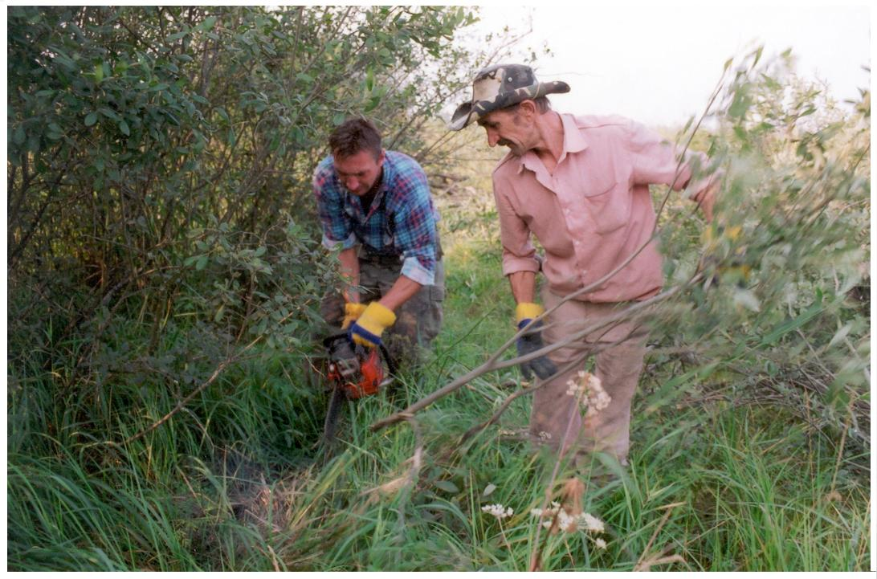 | 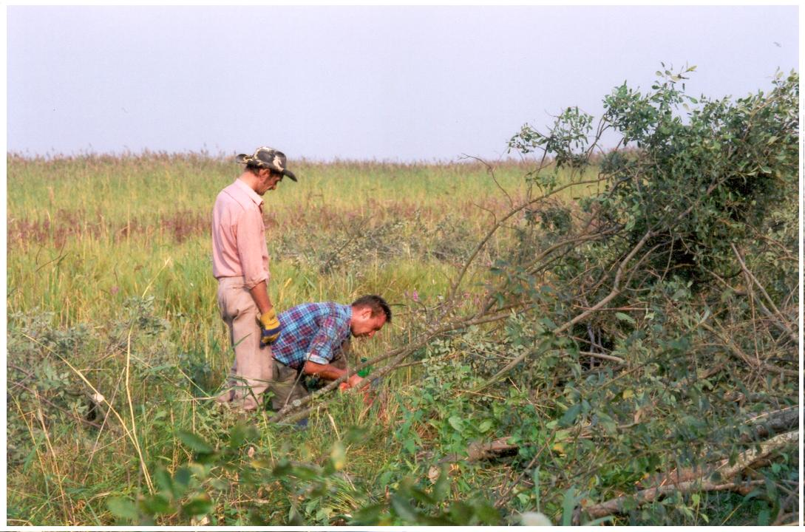 | 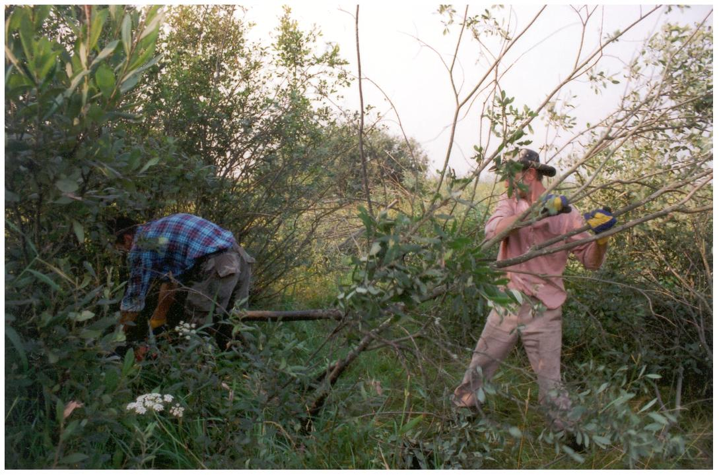

ACTION C.2:

Name of action: Purchase of reed cutting machine
Time plan: IV 2001 – II 2002

Progress: In 11/04/2002 the contract was signed between Dorotea Mekaniska AB and Latvian Fund for Nature (please see attached Contract in Appendix 3). Based on this contract, the reed cutting machine TRUXOR DM 4700 was delivered to Engure from Sweden in June 4, 2002.
The introduction on using and repairing the machine was given to the staff of LENP in June 5-10, 2002. First patches of reed were cut already in 5th June. At the moment machine is working well and being used for reed cutting in eastern part of the lake and around islands. 90 ha of reed have been cut until 8 August, 2002. No reed cutting for commercial purposes will be done this year due to large amounts of areas to be cut for nature conservation purposes.
The machine has also the additional equipment for deepening the channels, as well as knives for cutting the small bushes and grass.
Small building, initially not foreseen in the project, has been constructed for keeping the machine. This storage house is very important in order to keep the machine in good working condition and store it during the winter months.

Variations/complications/delays: NO
Additional information: Pictures C.2. in Appendix 2.
Contract No K02043, 11/04/2002 in Appendix 3.

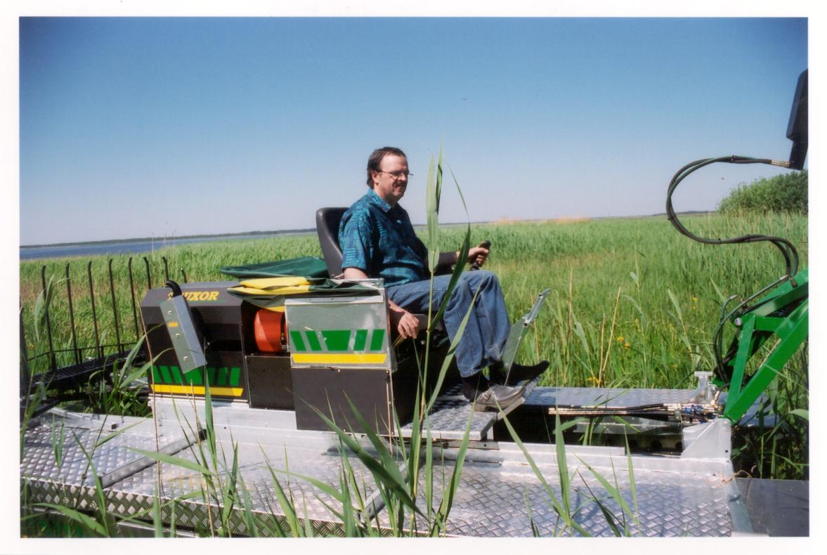 | 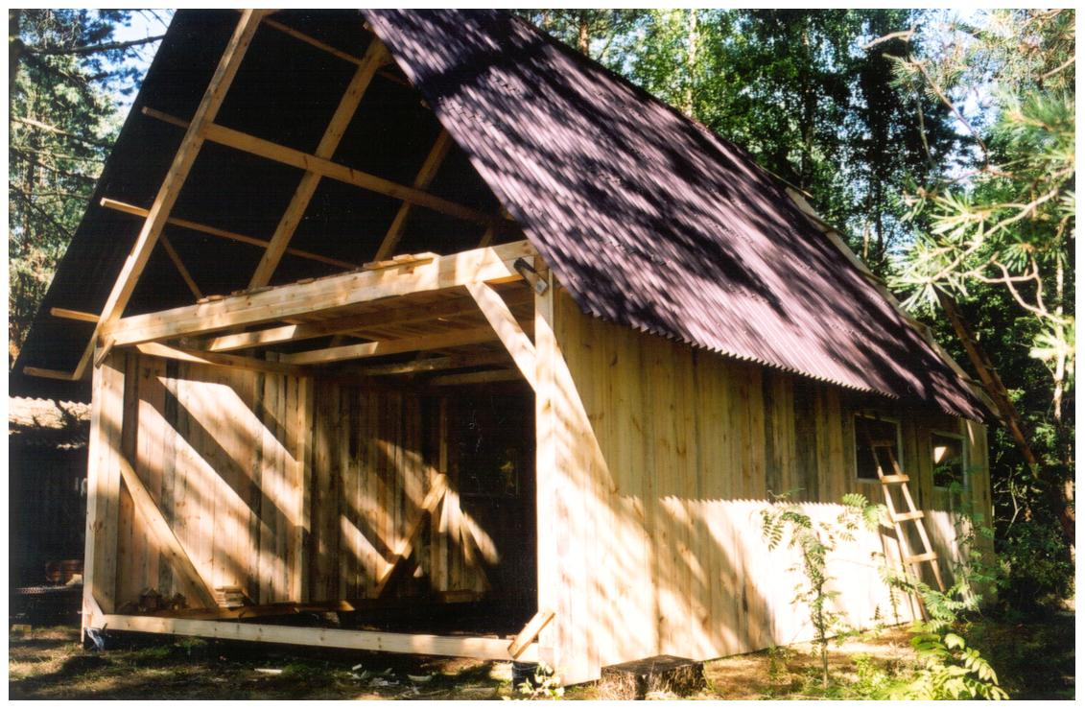 | 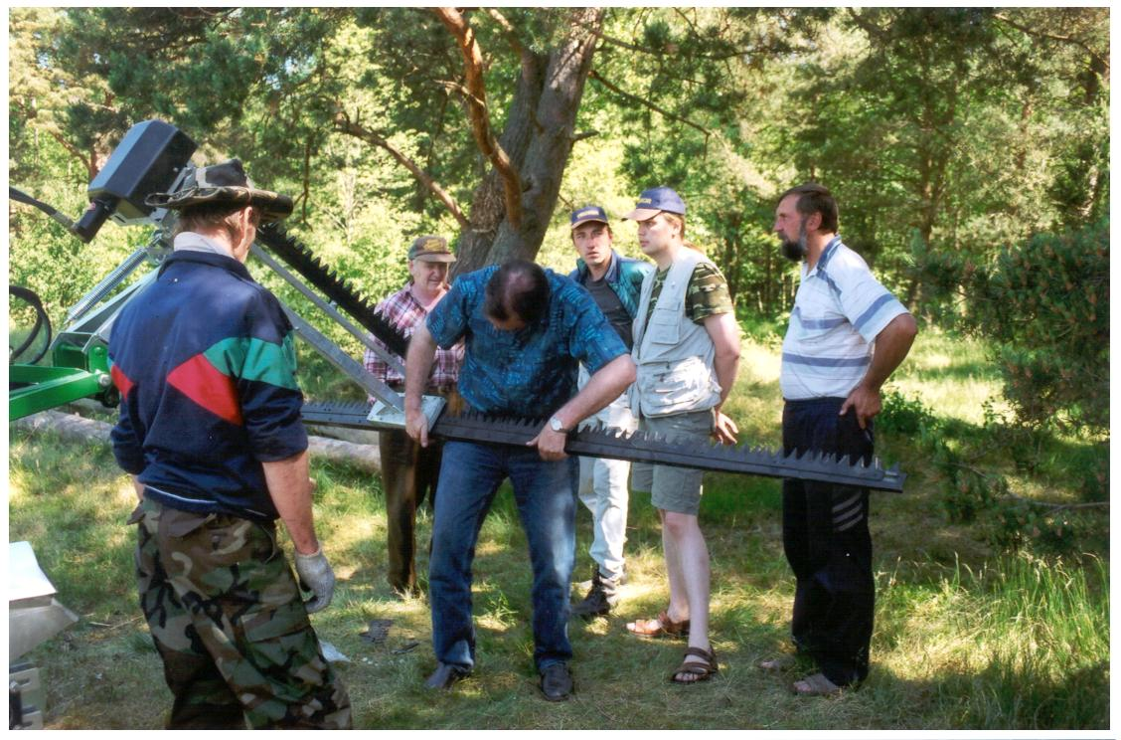

ACTION C.3:

Name of action: Purchase of cattle for grazing management in LENP
Time plan: I-II 2002

Progress: In the project proposal it was foreseen that cattle would be bought in Sweden. By the time project begun, the cattle, meeting our requirements (able to live outside all year round, no need for milking and minimal requirements for additional feeding) was also available in Latvia. Therefore, we changed our plans and decided that most of the cattle has to be bought in Latvia, thus avoiding custom problems and supporting Latvian farmers. First cattle for the project (3 cows, 1 year old, mixture of Highlander and Sharole breeds, + 1 Latvian Brown cow adopted for living outside all year long) was bought in January, 2002. They have been placed on first restored meadow in August. Then additional 4 cows of Latvian Brown and 2 cows, mixture of Latvian Brown and Sharole were bought in March, 2002. We have signed the agreement with farm “Kalna Berzini”, located in Zaube, who is breeding the cattle for nature conservation purposes. The agreement foresees that during the project, 6 of our cows will be kept with the farmer in Zaube (who will ensure the breeding of these cows with Highlander bull) and the offspring of these animals will be sold to the project for cheaper price. This way we ensure that 6 calves will be added to our herd every year on top of the offspring obtained from cattle placed in Engure.
In addition to this cattle, we have also purchased one 2nd year bull (named Uku, crossbread of Highlander and Aberdeen Angus), from farmer in Matsalu reserve, Estonia.

Variations/complications/delays: Variation from the initial project proposal is that cattle is being bought in Latvia, instead of Sweden. One bull is also bought in Estonia. The reasons are described in Progress section. Instead of pure meet cattle breeds we are introducing mainly mixtures with local breed Latvian Brown, obtaining animals who are more adapted to the local environment.
Additional information: Pictures C.3. in Appendix 2.
Contract, signed with the farm “Kalna Berzini”, 02/01/2002 (in Latvian, with summary in English) in Appendix 3.

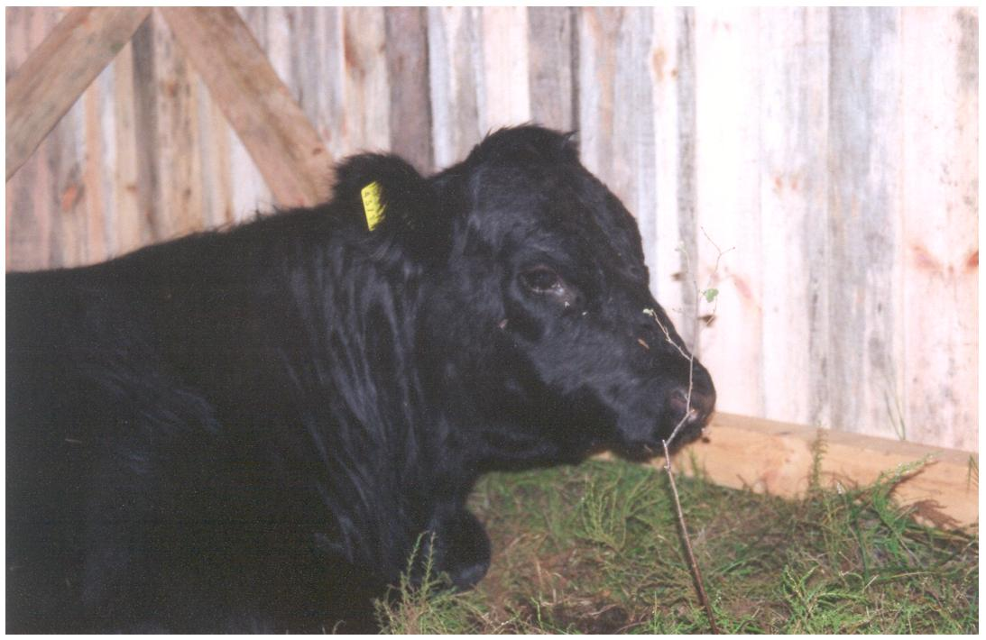 | 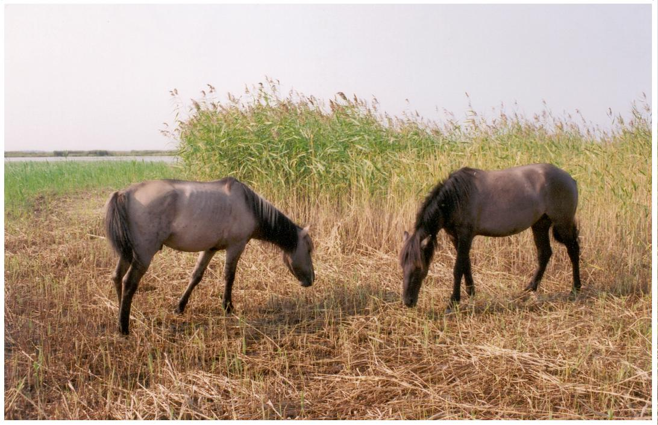 | 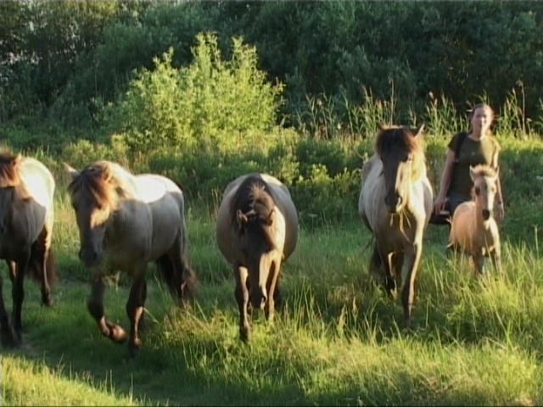

ACTION C.4:

Name of action: Building of fences for keeping the cattle
Time plan: II 2002, I 2003, I 2004.

Progress: 20ha of the first restored meadow have been fenced, the length of fencing is 2,350 m. Locally made wooden poles were used to construct the fence, in combination with metallic wires. Local people were employed to perform this task. The works were carried out in 4 – 30 June.
Also small shelter has been build within the fence, to have the place where cattle can hide from the wind and have some hay in winter months.
It is planned to build approximately 3,500 m of fence in year 2003.

Variations/complications/delays: NO
Additional information: Pictures C.4. in Appendix 2.
D. Recurring management

ACTION D.1:

Name of action: maintaining shore, island and coastal meadows and calcareous fens by grazing. Taking care of the cattle.
Time plan: III 2002-III 2004

Progress: 4 cows (3 one year old cows, mixture of Highlander and Sharole breeds and one Latvian Brown cow adopted for living outside all year long), mentioned in Action C.3.) have been placed on meadow #1 (restored area, mentioned in Actions C.1., C.3. and C.4.).

1 Highlander x Aberdeen Angus bull (1 year old, named Uku) has been bought in Estonia. This is the added value of the Study Tour – we are happy that due to this Study Tour we managed to find the bull for Engure, for reasonable price. There is only one Highlander bull in Latvia and obtaining Uku is a success for our cattle breeding programme.

In addition to these animals, a group of five Konik horses have been also placed on the same area. Konik horse is the old breed of horses, closest relatives to the wild horses. They are being used for natural grazing in Europe. The placement of Koniks was not foreseen in the project, but there are several reasons for introducing this small herd in Engure:
- The areas to be maintained by grazing are large and amount of cattle is not sufficient, to cover all the areas, especially in the initial phases of the project.
- There is an argument between nature conservationists, supporting natural grazing and semi-natural grazing approaches. In our project we are following the principles of semi-natural grazing, as we think that it is more beneficial for local population. But we also want to keep the other options open and test the approach of natural grazing in Engure. Probably, the mixture of both approaches will be the best solution for Engure.
- Cattle and horses have different grazing patterns. Mixing them, we ensure that meadow is better grazed.

Considering reasons, mentioned above, we begun our negotiations with ARK foundation (based in Netherlands). As a result of these negotiations we obtained 5 horses, as a gift (for more details, please see attached contract, signed between Stichting ARK foundation and Lake Engure Nature Park fund, in 15/02/02).

In the project proposal it was foreseen, that optimum amount of animals to be placed on meadow #1 is 25. Based on the Estonian experience (gained during the Study Tour described in Action F.3.), we have lowered necessary number of animals and decided that approximately 15-20 animals, grazing all year long would be optimum for meadow of 20 ha size.
At the moment we have 4 cows, 1 bull and 5 horses placed on the meadow. Approximately 5-10 more animals are needed on this meadow, to ensure optimum grazing pressure. When more animals are being born on top of this number, we will move them to the other areas.

Variations/complications/delays: Variation #1 from the initial project proposal is that cattle used for grazing is purchased in Latvia, instead of Sweden. One bull is also bought in Estonia. The reasons are described in Progress section of Action C.3.
Variation #2: Instead of pure meet cattle breeds we are introducing mainly mixtures with local breed Latvian Brown, obtaining animals who are more adapted to the local environment.
Variation #3: In addition to cattle foreseen in the project, a herd of 5 Konik horses have been placed in meadow #1. The reasons for this have been described in Progress section.
Variation #4: In project proposal it is foreseen that cattle will be placed on Lielrova island in 2002. At the moment, no cattle have been placed on the island. We want to study the behaviour of the cattle to be sure that they will not leave the island when ice is on the lake. We also want to educate local people before placing the cattle on the island, to ensure that it will not be stolen.

Additional information: Pictures D.1. in Appendix 2.
Contract, 15/02/02 in Appendix 3.

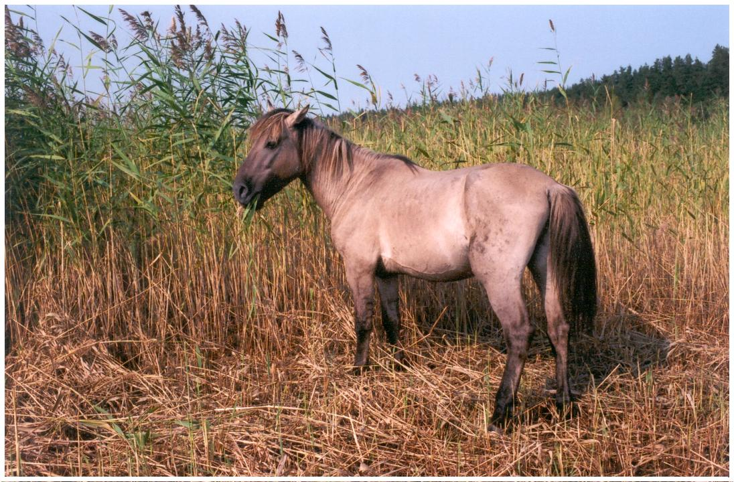 | 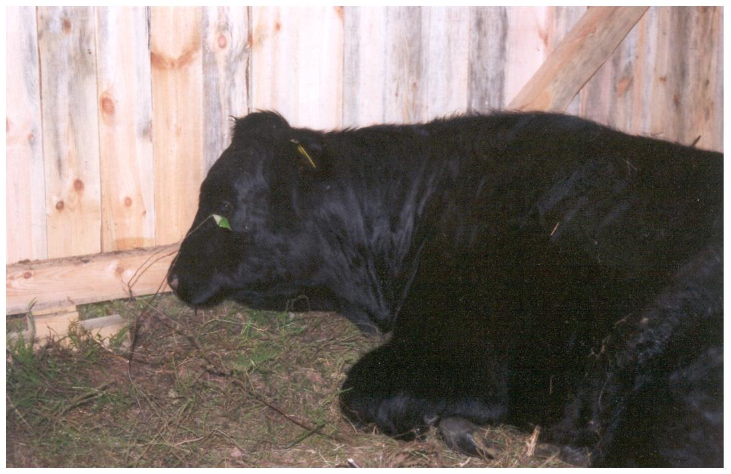 | 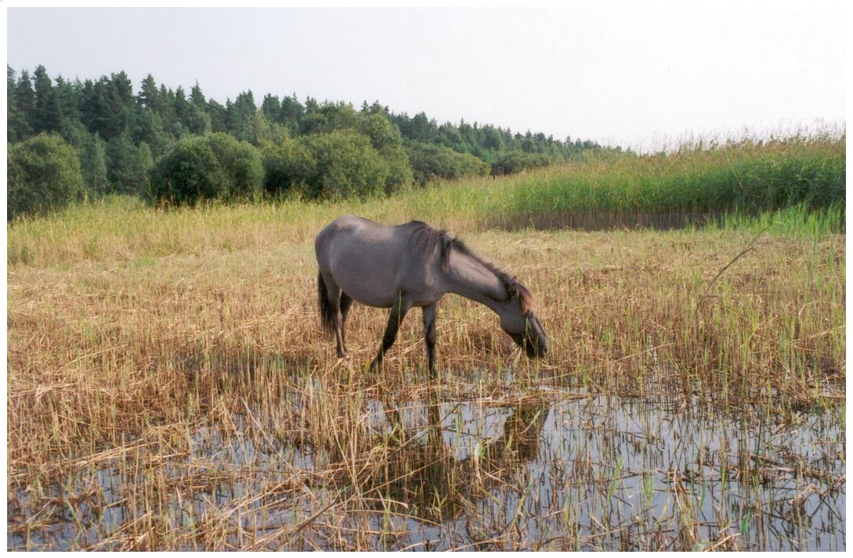

ACTION D.2:

Name of action: reed cutting
Time plan: III 2002, III 2003, III 2004.

Progress:
Reed cutting has begun in Lake Engure. Reed cutting machine Truxor DM 4700B (purchased under Action C.2.) has been working in Lake Engure since 5 June, 2002. The machine has been working full time from 12 June, 50ha of reed have been cut until September 15, mainly along the eastern coast of the lake (19ha) and around the islands (6ha around Lopsalrova, 5ha – Kazrova, 20 ha – Lielrova). The reed cutting is very difficult this year, due to extremely low water level. If water level rises, it would be possible to cut another 10-20 ha of reed until the end of October.

Variations/complications/delays: the total area to be cut per year, established in project proposal (330ha) will not be met in 2002, due to the fact that machine has been recently delivered and project staff is still learning to use it. But we plan to fulfil the obligation of 330ha in 2003.
Additional information: Pictures D.2. in Appendix 2.

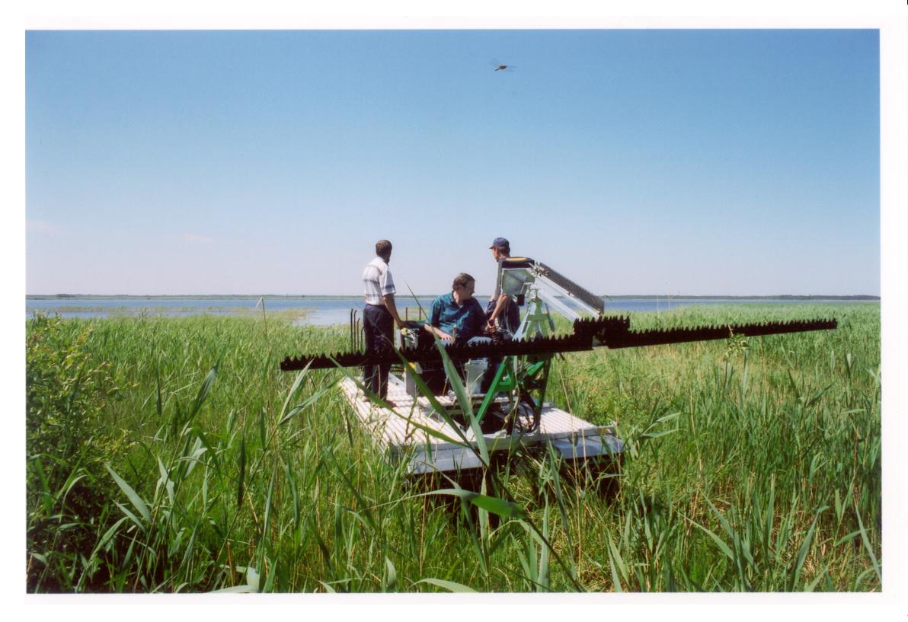 | 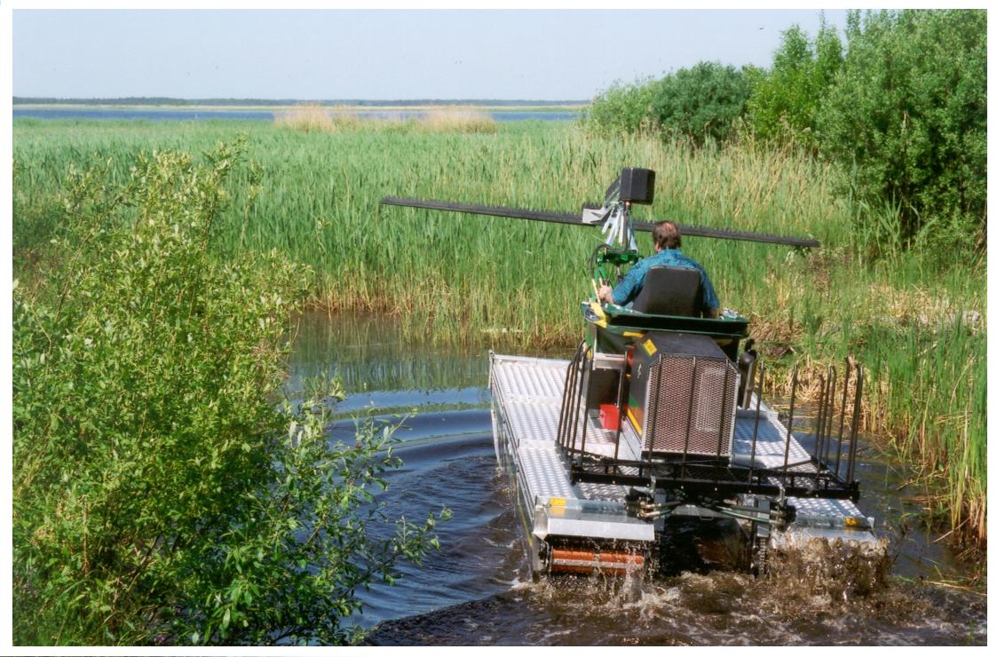 | 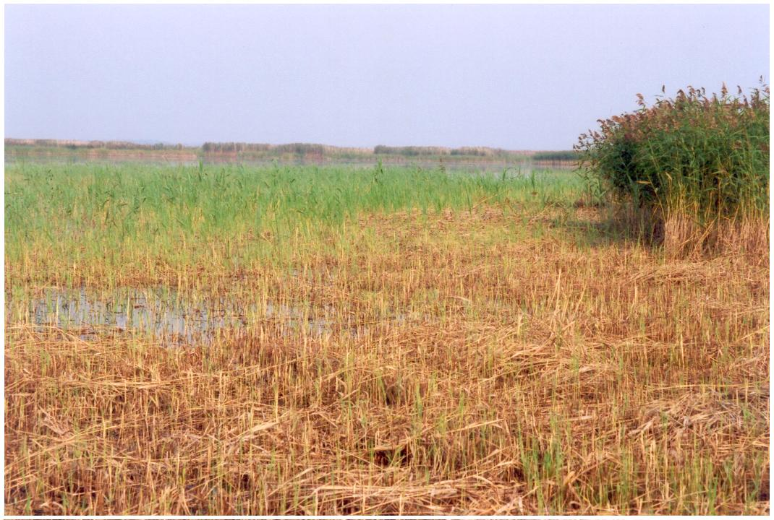

ACTION D.3:

Name of action: monitoring the effect of management measures on habitats and species
Time plan: II 2002 – III 2004

Progress: This monitoring programme is focusing on areas where management measures are implemented – in year 2002 it is meadow #1 and areas where reed is cut in the lake. The state of all the management areas is being recorded before management measures are taken and following each year, to register the changes.
The monitoring programme has been successfully launched in 2002. The ornithological inventory has been conducted both in lake and on meadow #1. Breeding birds were recorded in period of April – June. Botanical inventory was conducted on meadow #1 in June 7 and July 2.
Data will be processed until October 2002.
An expert (Dr. Otars Opermanis) will be hired to elaborate the system of management indicators. Mr Mike Alexander, well known management planning expert from Countryside Council of Wales provided his advices and comments and consulted Dr. Opermanis during his visit to Engure in May 31 – June 1, 2002.

Variations/complications/delays: Elaboration of management indicators may be delayed until Spring 2003, but this will not affect the effectiveness of monitoring, because enough data have been gathered in 2002.
Additional information: Pictures D.3. in Appendix 2.

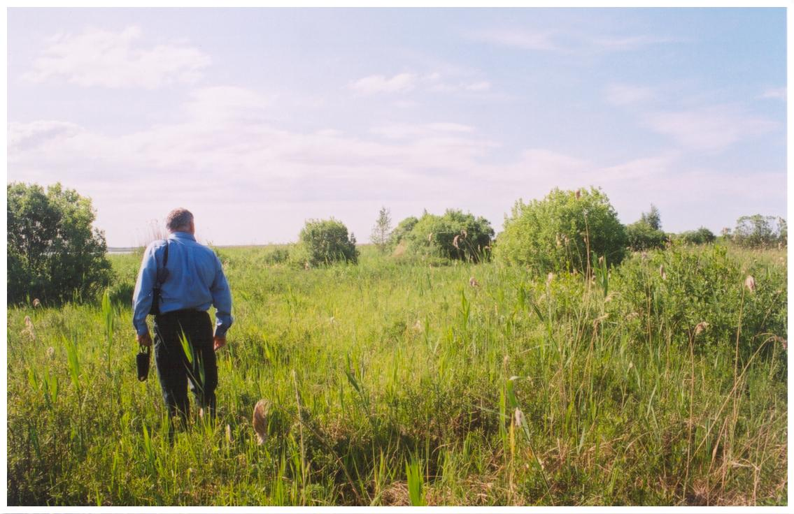 | 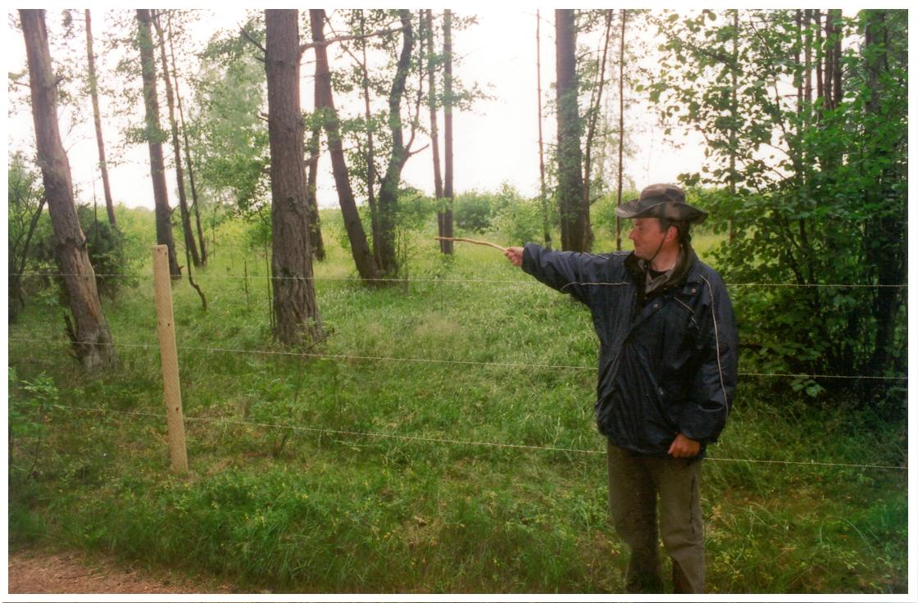 | 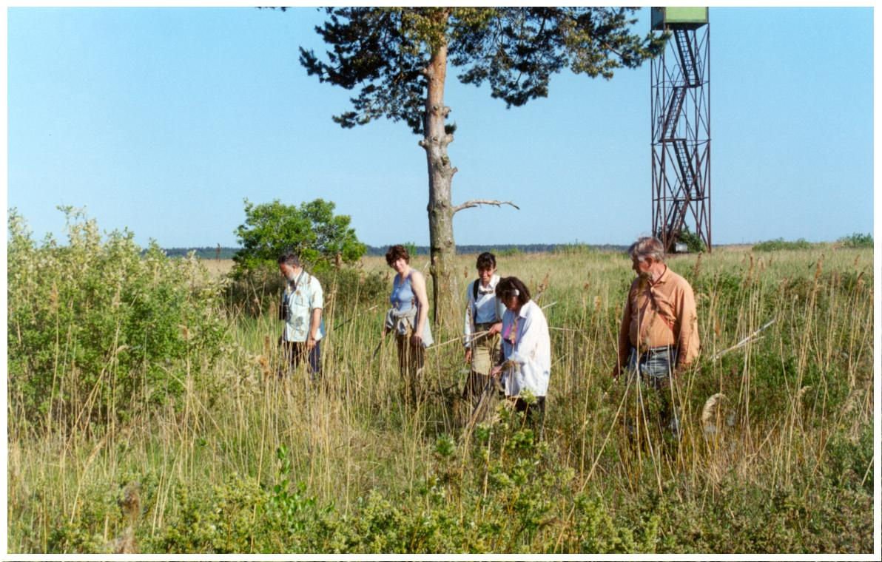

ACTION D.4:

Name of action: ensuring adequate control and protection in Lake Engure Nature park.
Time plan: IV 2001 – III 2004

Progress: 2 inspectors were hired in January, 2002. One of them is from local village Mersrags, the other is from Tukums town. Up to now, their work was mainly concentrated on the lake, as most illegal activities are carried out there. 62 illegal fishermen have been registered and 8,045 m of illegal nets have been confiscated. The duck hunting season is opened in 17 August this year, there will be a lot of work for inspectors in order to ensure that hunters are following the regulations established in Engure. The inspectors have been also helping with setting up the signs and taking care of the cattle.
2 cars – Seat Ibiza and VW Caravelle have been purchased for Lake Engure Nature park. They are used for inspection and transporting building materials. VW Caravelle was also used during the Study Tour to Estonia, thus minimising the costs of the Study Tour.

Variations/complications/delays: Inspectors were hired 3 months later than foreseen in the project, the delay occurred due to the fact that it took more time then expected to find the appropriate candidates.
Additional information: Pictures D.4. in Appendix 2.

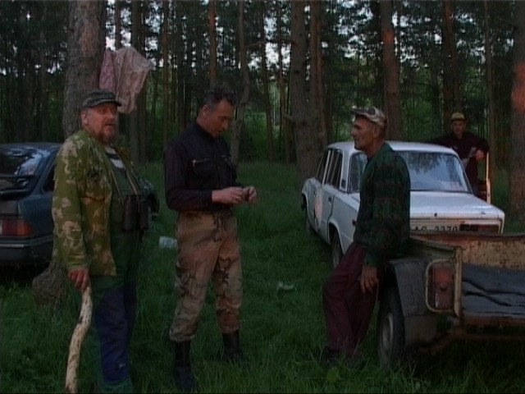 | 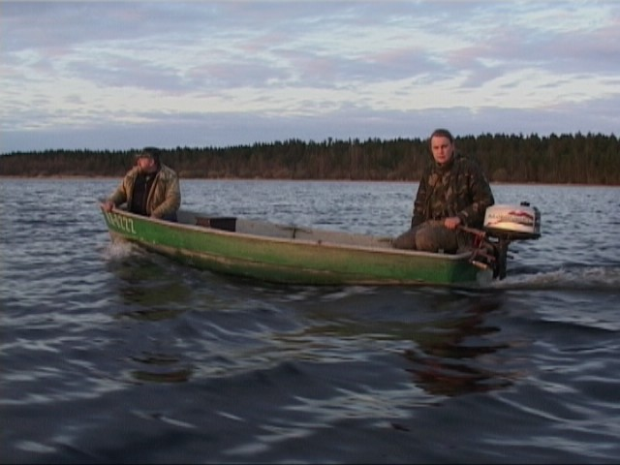 | 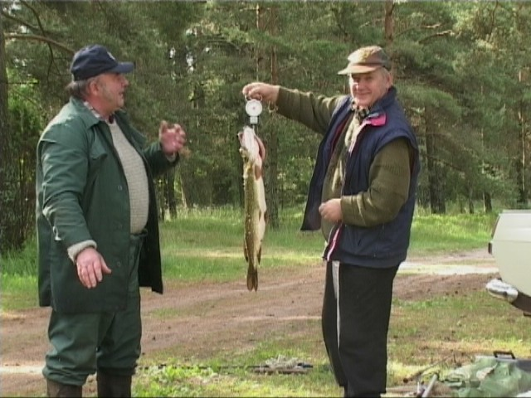

E. Public awareness and dissemination of results

ACTION E.1:

Name of action: Building of summer lecture room
Time plan: I-II 2002

Progress: The cost of building summer lecture room will be higher than expected in the project proposal. Therefore, in order to lover the costs of building, we are not planning to contract the building company. Instead, the building works will be carried out by contracted workers and managed/coordinated by Lake Engure Nature park fund. By organising the works in this manner, we can keep the price of the lecture room within the planned budget.
Before beginning the building works, the contract about long term lease of the land under summer lecture room has to be signed with owner of the land – Institute of Biology, University of Latvia. Due to the fact that they have not registered their land in Land Register yet, the signing of contract has been delayed. But they are working on papers now and as soon as the land is registered, the contract will be signed. The project of the lecture room is ready and submitted to building department for acceptance. As soon as contract with Institute of Biology is signed and project accepted by building department, building works will be started. The lecture room will be finished by 1 June 2003.

Variations/complications/delays: The activity will be delayed due to the reasons mentioned in Progress section. Nevertheless, it is planned to begin the building works (building fundament, basis and putting on the roof) in 2002 and finish them by 1 June 2003. The activity will not be subcontracted.
Additional information: Draft contract E.1. with Institute of Biology in Appendix 3 (in Latvian, with summary in English).

ACTION E.2:

Name of action: Construction of two 8-10 m high bird watching towers at the lake Engure.
Time plan: I 2002, I 2003

Progress: The organisation of building works in manner, described in Action E.1. will be used also for this action, in order to save money. Therefore, for the same amount of money we can build the towers of better quality than we could afford if we had to pay the building company for managing the building works. The building of first bird watching tower (at the boat station No3 in Mersrags) was begun in August 2002 and finished in September 2002. The second bird watching tower will be built in the beginning of 2003, as foreseen in the project proposal.
Another achievement of the project is that Mersrags municipality has entrusted the right to manage one of the boat stations (No 3, where first bird watching tower is being constructed) to the Lake Engure Nature park fund. This is a very good sign of willingness to cooperate from Mersrags municipality. For Lake Engure Nature park, this is good opportunity to develop nature friendly tourism infrastructure. The first bird watching tower is in construction now, notice boards to inform people about the LENP and project will be set up and in future, if additional funds become available, the infrastructure of this station will be improved to support the nature friendly recreation.

Variations/complications/delays: Building of first bird watching tower is delayed, but it is in process now. The action will not be subcontracted, for the reasons described in Progress section.
Additional information: Pictures E.2. in Appendix 2.

ACTION E.3:

Name of action: Setting up notice boards and border signs at LENP
Time plan: IV 2001-I 2002

Progress: The signs, acknowledging LIFE support, with name of the project have been set up on all the constructions, made within the project (fence for the cattle, cattle shelter, storage house for reed cutting machine, bird watching tower) and will be set up on all the constructions completed in due time.
The signs, marking the reserve zone of the Nature park have been also set up in March, to ensure that people are informed about border of reserve zone, where no fishing and hunting is allowed.
The notice boards, informing people about LENP, values and rules will be set up near the bird watching towers and in villages, as well as in boat stations around lake Engure and parking places near the seacoast. These notice boards are not ready yet, due to the fact that designer we would like to contract for this work is busy with making the signs for WWF Pape project. But as soon as she has finished the assignment with WWF (in October, 2002) we will contract her to design our notice boards. We would prefer to have this designer for our notice boards, due to the very good quality of her work. In addition, we are planning to make small notice boards, describing most common and most valuable animals and plants in LENP and set these boards along the tourist path and at bird watching tower.

Variations/complications/delays: Designing notice boards will be delayed due to reasons mentioned in Progress section. In addition to notice boards, smaller boards describing important plants and animals will be set up. The activity is planned to take place in October 2002 – February 2003.
Additional information: Pictures E.3. in Appendix 2.

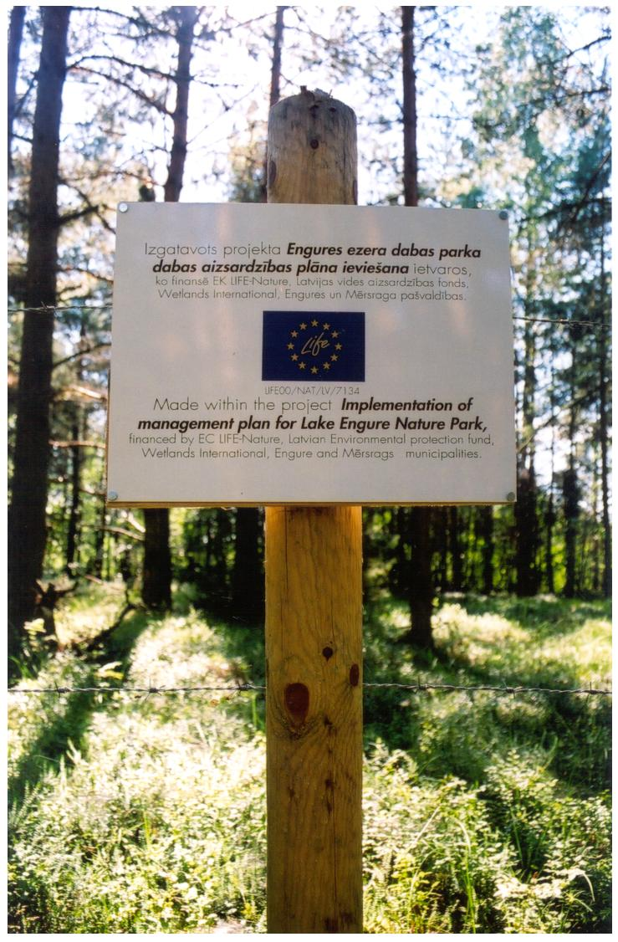 | 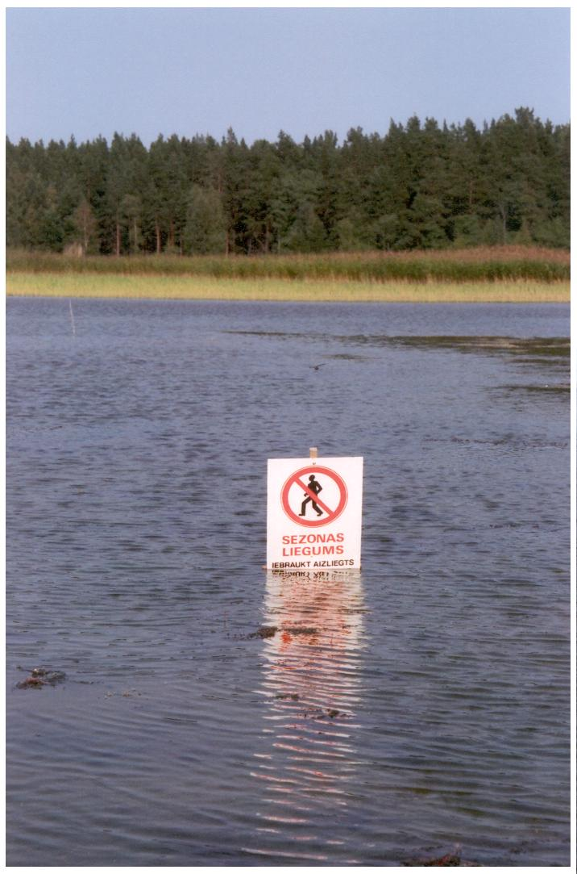 | 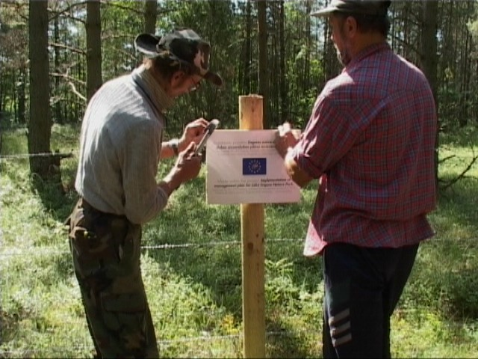
 |  | 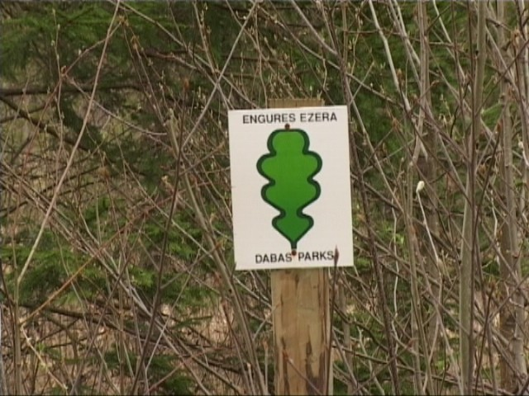

ACTION E.4:

Name of action: Construction of nature/tourist path
Time plan: I-II 2003

Progress: According to the time plan, activity has not begun yet. The signs for setting along the tourist path will be made as described in Action E.3.

Variations/complications/delays: NO
Additional information: NO

ACTION E.5:

Name of action: Printing 3 booklets about Lake Engure Nature park and LIFE project.
Time plan: IV 2001, I 2003, II 2004

Progress: The first booklet was printed in 1000 black and white copies, as foreseen in the project, at the end of 2001. It was distributed for the local people in villages Mersrags, Engure and Berzciems. It was also distributed to the municipalities and used by staff of Latvian Fund for Nature as handout material to inform about the project.
The next booklets will be issued as foreseen in the project.

Variations/complications/delays: NO
Additional information: The booklet in Appendix 4 (as printed, in Latvian) with attached translation of the text in English.

ACTION E.6:

Name of action: publication of park periodical
Time plan: I 2003 – III 2004

Progress: According to the time plan, activity has not begun yet. In the initial project proposal it was foreseen that periodical will be issued by staff of the Information centre. Since information centre has been cancelled from the project, we have to contract the additional person for this task. Probably the periodical will be issued as addition to the local newspapers (e.g. “LENP news”, or “Nature page”), to ensure its wider distribution. It will be also available at the boat stations and in municipality houses.

Variations/complications/delays: NO
Additional information: NO

ACTION E.7:

Name of action: Organising seminars
Time plan: IV 2001, I 2003, II 2004

Progress: First seminar of the project was organised in 07.01.2002. in Engure municipality house. The following representatives attended the seminar: representatives from Engure, Mersrags, Kulciems and Zentene municipalities, State Forest service, State Fisheries board, Institute of Biology. This seminar was organised more as information to the stakeholders and invitation to cooperate.

Several smaller events have been organised in December 2001 to August 2002, as meetings of Engure Council. In these meetings project staff informed the members about the progress of the project and discussions took place. On the level of heads of local municipalities, they are very willing to cooperate. At the same time, on the level of local people, rather sceptical attitude is remaining. We are going to organise more events to address local people directly, not via municipality leaders. One of the events planned in September is meeting with the local people where participants of the Study Tour to Matsalu and Hiiumaa in Estonia (for more information see Action F.3.) will tell their fellow villagers about their impressions and experience gained.

Smaller face to face meetings have been conducted during Summer 2002, when project managers were visiting local people at their houses, talking about the project and learning from local experience. As a result of these meetings, several facts about the local attitude towards nature conservationists were revealed. Due to the negative experience with nature conservation policy in Soviet times, people are still very suspicious and reluctant. But only way to get them onboard is by talking face to face and explaining our goals, showing them that nature conservation and local economy objectives are not so different and we can achieve them by common means.
One of the positive outcomes of such meetings is mutual agreement between Lake Engure fund and local reed cutters about the areas on the lake where reed will be cut by project and where by local people. There have been cases before, when reed cutting for nature management purposes was done in areas where local people were used to cut the reed and this caused many disagreements.

The second project seminar was held earlier than planned – in August 25-28,2002. More than 70 participants attended the seminar, representatives from Regional Environmental Boards, State Forest service, administrations of protected areas, Ministry of Environmental Protection and Regional Development, NGOs. The seminar was organised in cooperation with Darudec EMERALD project, and by joining the efforts (and budget) of 2 projects we were able to organise 3 day seminar instead of 2 day seminar and to invite more people. The seminar was organised in following way (please see also attached programme of the seminar in Appendix 5):
1st day of the seminar was dedicated to the management planning process in Latvia, with practical examples from Latvia and other countries.
2nd day of the seminar was dedicated only to Engure LIFE project. In the morning, presentation of project goals and achievements was given by project manager Inga Racinska (Please see the presentation in Appendix 5). The presentation was followed by field excursion to Lake Engure, with practical demonstrations of project activities and presentations by Dr.Janis Viksne (bird values of the Lake Engure and previous management of the lake) and inspectors hired for the project (Action D.4.).
The excursion was followed by groupwork, the participants were given the assignments, related to the Engure LIFE project. They had to interview the local people, to get the view on interests of local population. Then this information had to be combined with information about nature conservation interests in LENP (obtained during morning presentation, excursion and from management plan for LENP), to prepare the recommendations to the project on how to improve the management of the LENP, combining interests of local people and nature conservation. (For more information on the working group assignments please see Appendix 5).
3rd day of the seminar was dedicated to the practical experience of nature management in Latvia. Among others, several present and potential LIFE-Nature projects were giving their presentations.

Variations/complications/delays: 2nd seminar of the project was organised earlier than foreseen in the project, to be able to show the activities of the project (such as reed cutting and cattle) in nature.
Additional information: Pictures E.7. in Appendix 2
Program and group assignments of the 2nd seminar in Appendix 5
Presentation about the project in Appendix 5

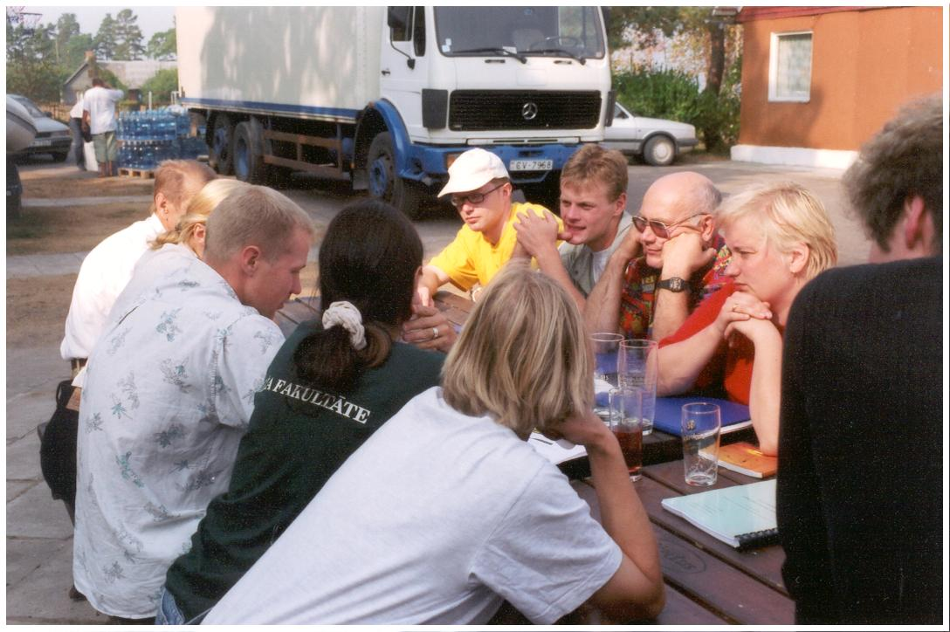 | 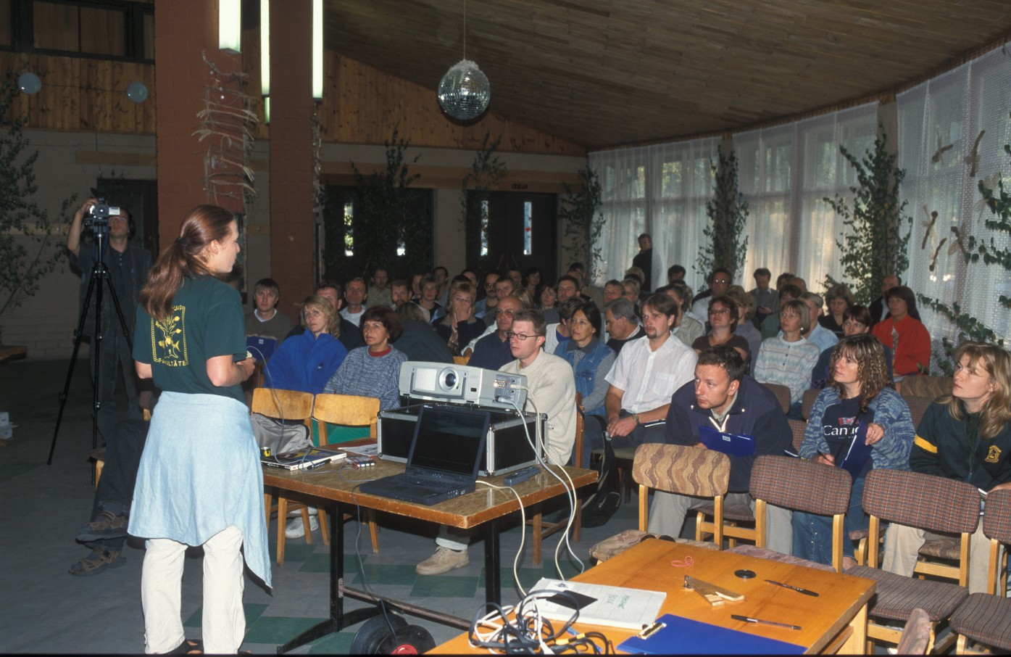 | 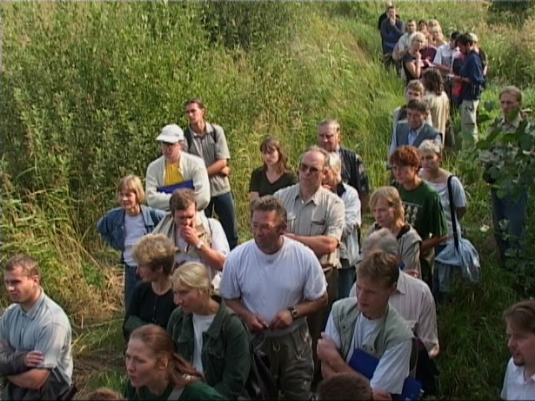

ACTION E.8:

Name of action: Film about Lake Engure Nature park
Time plan: II-III 2003

Progress: In the project proposal it was planned to make the film, documenting the activities of project. After discussions with professionals from Nature Film studio, we decided to aim for more serious product and create the documentary about people of LENP, their past and present, about their interests, combined with new nature conservation approach, represented by the project. The new conception is very interesting – to show how the project staff is slowly changing the attitude of the local people towards nature conservation. It is planned to be 30 minutes film, shown on national television and in international nature film contests (e.g. Sundsval festival in Sweden). The budged, allocated in the proposal is not enough to create such a serious product, therefore we are not subcontracting any filming company, but producing the film ourselves. For this purpose we have purchased filming equipment and we hiring required specialists directly (Mr Kaspars Goba, has been hired as film director and operator, and additional specialists are hired on the short term contracts, when necessary). The equipment, purchased will be used for documenting the activities in the Lake Engure Nature park also in future. We have also agreed with Nature Film studio about their logistical support to the film, they are also providing us with extra equipment, when necessary. Filming begun in January 2002 - earlier than planned, to have one full year for filming the material and in order to include all the major project activities. Up to now, 20 h have been filmed, including all the project activities and interviews with local people. The filming is going according to schedule and we are planning to have the product by the end of year 2003.

Variations/complications/delays: Project itself is producing the film (thus to avoid overhead and extra costs), instead of subcontracting the filming company as foreseen in proposal. The reasons for this change are described in Progress section. Filming works have begun earlier than planned, in order to have one full year for filming.
Additional information: Pictures E.8. in Appendix 2

ACTION E.9:

Name of action: Creating home page of LENP and LIFE project
Time plan: IV 2001

Progress: Producing the home page have been delayed, but it is in the process now. The reason for delay is that home page of Latvian Fund for Nature was under construction until August 2002. Since home page of LENP and project is to be designed within the home page of Latvian Fund for Nature and placed on its server, these modifications have influenced this project action. Nevertheless, the new home page of Latvian Fund for Nature was launched in September 2002. It contains summary of the project, as well as news of the project, pictures of the activities. Home page is in Latvian and English. There is also link to LIFE Homepage. This report has been also placed on the homepage.
Home page can be found on www.ldf.lv. Information about project in English can be found on http://www.ldf.lv/pub/?doc_id=27945

Variations/complications/delays: Activity was delayed due to reasons described in Progress section.
Additional information: Printouts of home page, containing information about project (in Latvian and English) in Appendix 8.

F. Overall project operation

ACTION F.1:

Name of action: Monitoring of project performance
Time plan: III 2002, III 2003, III 2004

Progress: Lake Engure Council meetings were held in December 2001, January and May 2002. Project managers were reporting to the Council members about the progress of project activities. Council approved the project activities and solutions to problems. Next Council meeting is planned in September/October 2002.
The interim technical report will be placed on home page as soon as the home page is operating.

Variations/complications/delays: NO
Additional information: NO

ACTION F.2:

Name of action: Administration of the project.
Time plan: IV 2001- III 2004

Progress: 2 project managers have been hired by the project on full time basis – Mr Roberts Šiliņš, director of Lake Engure Nature park and Ms Inga Račinska – project manager from Latvian Fund for Nature.
1 accountant has been hired on half time basis, responsible for controlling the financial aspects of the project and financial reports, as well as for reporting to Lake Engure Council on meetings, dealing with financial matters.

Variations/complications/delays: NO
Additional information: CV of Inga Račinska and Roberts Šiliņš in Appendix 6.

ACTION F.3:

Name of action: Study Tours to Vainameri (Estonia) and Hornborga (Sweden)
Time plan: IV 2001, II 2002

Progress: One Study Tour has been organised in 24-27 July, 2002 – to Vainameri (Matsalu and Hiiumaa) in Estonia. 7 persons participated in the Study Tour – 2 local people from Mersrags, 2 persons from Kulciems, both project managers and director/operator of the project film. Study tour was very informative and we are planning to organise another Study Tour to Vainameri in 2003. We are planning to take more local people to this area, where many challenging things have been done in field of using cattle for grazing in protected areas, involving local people in nature management and supporting local economy. The Study tour was very useful also for project managers, as we learned about Estonian approach to involving local people in nature conservation activities. Estonia is ahead of Latvia in terms of securing funds to support the farmers, willing to begin nature friendly farming and the experience of Matsalu and Hiiumaa project staff was very useful. As continuation of the Study Tour, we are planning to organise the meeting in Kulciems village in September, where our participants of the Study Tour will share their experience and impressions from Study Toru with their neighbours. This event will be also organised in order to identify potential farmers for cooperation on grazing in 2003 (according to the project, we will sign the contract with local farmers in Kulciems on keeping the project cattle and ensuring its grazing in areas necessary for the project).
The second Study tour was planned in Sweden, but this decision was based on plan to buy the cattle in Sweden. Since project is buying cattle in Latvia (for the reasons, explained in Progress section of Action C.3.), there is no obvious need to organise Study Tour to Sweden.
Instead, we are planning to organise more Study tours to Estonia – one for farmers, with whom we will sign the contract for keeping the cattle. The other tours could be organised depending on local situation, probably for reed cutters or for people interested in development of local handicrafts.

Variations/complications/delays: Study tours will be organised to Estonia, for the reasons explained in Progress section. There will be more tours than planned organised, for different interest groups.
Additional information: Pictures F.3. in Appendix 2
Program of the Study Tour in Appendix 7

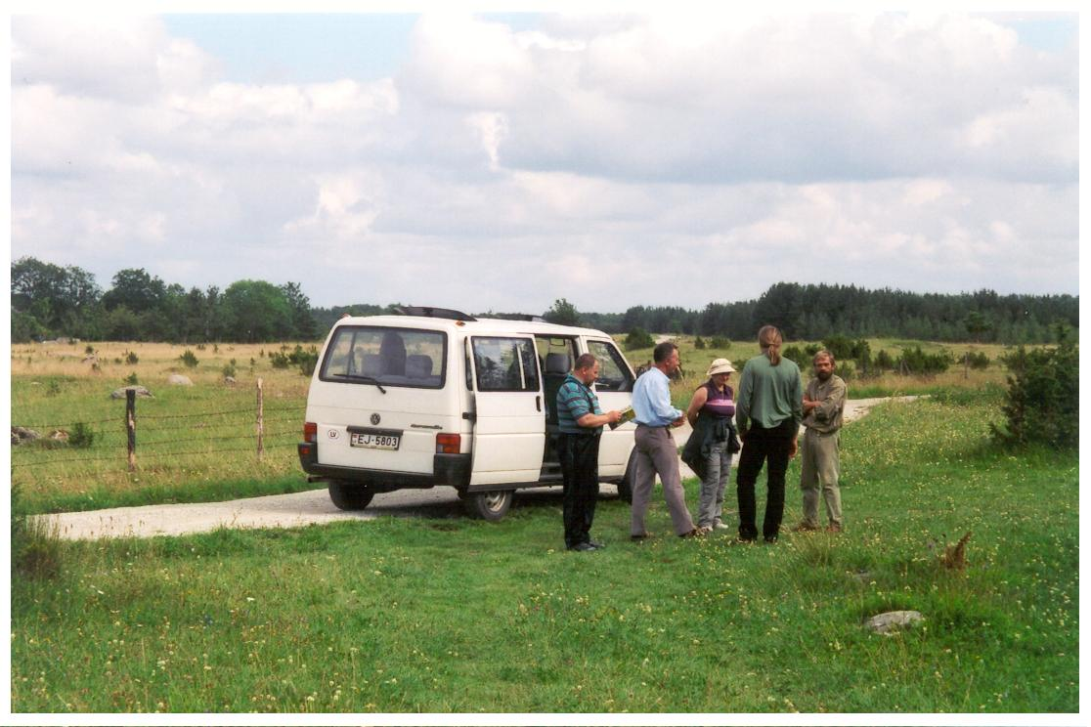 | 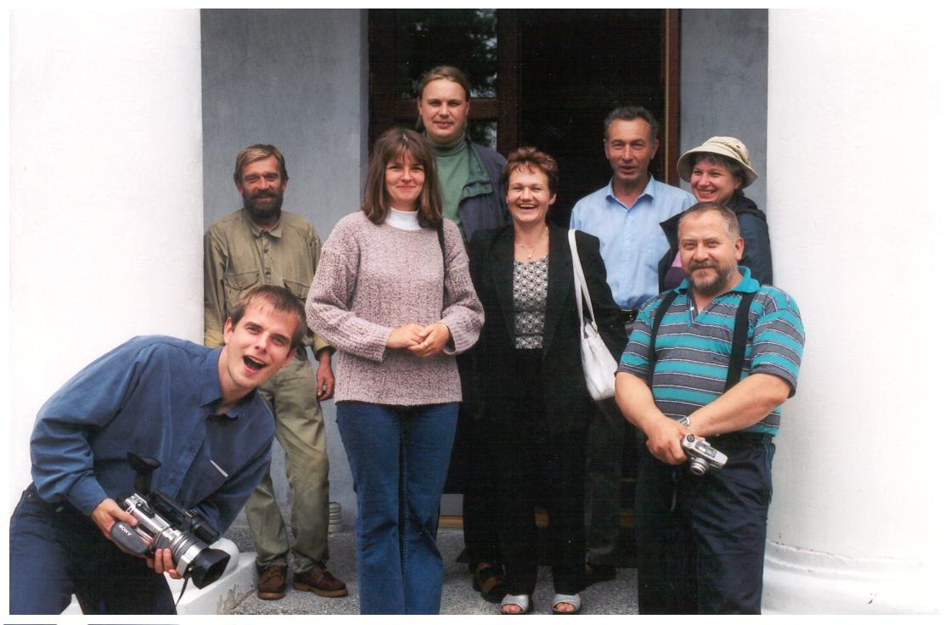 | 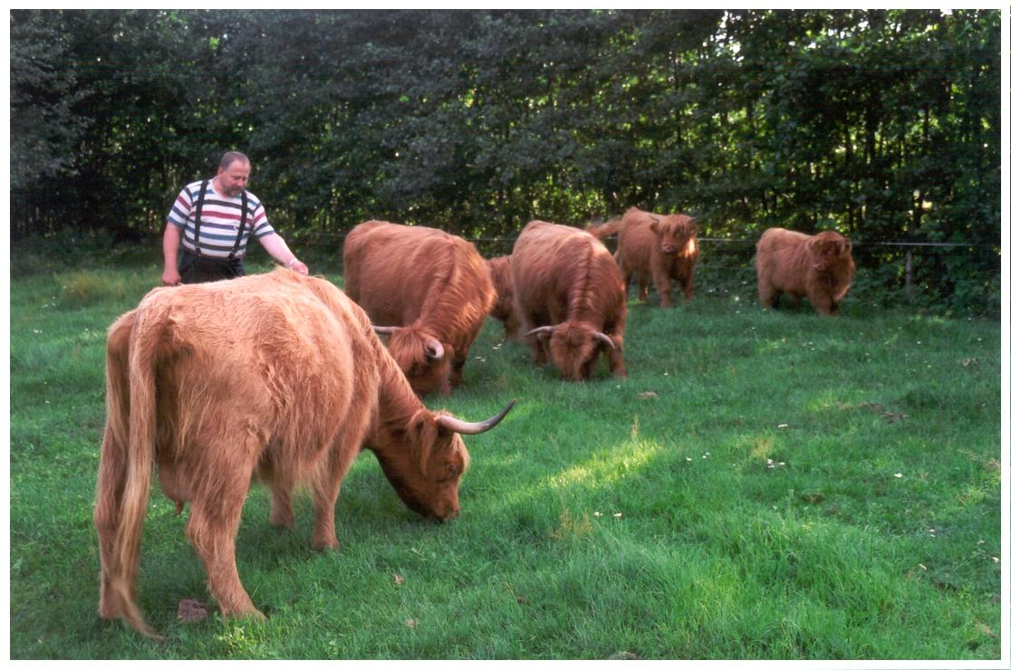

ACTION F.4:

Name of action: Independent audit of the project
Time plan: III 2004

Progress: According to the time plan, the activity is not started yet.

Variations/complications/delays: NO
Additional information: NO

